# 

# Department of Computing

# CS114: Fundamentals of Programming

# Class: BESE 9 AB

# Lab 07: Conditional Processing & For Loop

**CLO2: Define basic algorithms for identifying and solving real world problems**

# Instructor: Ms. Hania Aslam

# Date: October 26th , 2018

# Time: 9:00am -12:00pm and 02:00pm -05:00pm

**Lab 07: Conditional Processing & For Loop**

**Introduction**

The purpose of this lab is to get familiar with usage of for loop in Python.

**Objectives**

The objective of this lab is to design solutions using conditionals and for loop in Python Scripted Mode.

**Tools/Software Requirement**

Python IDLE

**Description:**

**For Loop:**

For-loops are typically used when the number of iterations is known before entering the loop. For-loops can be thought of as short-hands for while-loops which increment and test a loop variable.

|  |
| --- |
| for temp_var in «sequence»:  «block» |

**Lab Tasks:**

**Using only the programming techniques that you have learned so far, perform the following tasks:**

**Note: All the tasks of this lab should be performed in Python scripted mode only.**

**Task 1:** Write a program using for loop that prints the following pattern. The sample output is as follows:

|  |
| --- |
| *  **  ***  ****  *****  ******  *******  ********  *********  **********  ***********  ************ |

[1.5 Marks]

|  |
| --- |
| Task 1 |
| #Add your Python Script code here. [1 Marks]  PROGRAM:    #Add the snap of output here. [0.5 Mark]  OUTPUT: |

**Task 2:** Write a program that reads a number (between 1 and 30) and print a line containing that number of adjacent asterisks using for loop. The sample output is as follows:

|  |
| --- |
| Enter a number between 1 and 30: 12  ************ |

Hint: You might want to change the default end value of the print function.

[1 Marks]

|  |
| --- |
| Task 2 |
| #Add your Python Script code here. [1 Marks]    #Add the snap of tasks execution here. [0.5 Mark] |

**Task 3:** Using for loops and where required if statement, write a program to check whether a number entered by a user is a prime number or not. As soon as the number is confirmed to be a prime number your loop execution should stop. Sample output is as follows:

|  |
| --- |
| Enter a positive integer: 29  29 is a prime number. |

**Hint:**A prime number, as you may remember, is any whole number ( greater than 1), whose only factors are 1 and itself, meaning it can't evenly be divided by any number (apart from 1 and itself)

[2.0 Marks]

|  |
| --- |
| Task 3 |
| #Add your Python Script code here. [1.5 Marks]    #Add the snap of tasks execution here. [0.5 Mark]  1.    2. |

**Task 4:** Write a loop that prints out all numbers between 6 and 30 that are not divisible by 2, 3, and 5.

[1.0 Marks]

|  |
| --- |
| Task 4 |
| #Add your Python Script code here. [0.5 Marks]    #Add the snap of tasks execution here. [0.5 Mark] |

**Task 5:** Consider the following list **:**

city_names = ['Karachi', 'Lahore', 'Islamabad', 'Istanbul', 'Melbourne', 'Paris', 'Berlin', 'London']

Create a program to print the above list as follows:

1. Karachi

2. Lahore

3. Islamabad

4. Istanbul

5. Melbourne

6. Paris

7. Berlin

8. London

[2.0 Marks]

|  |
| --- |
| Task 5 |
| #Add your Python Script code here. [1.5 Marks]    #Add the snap of tasks execution here. [0.5 Mark] |

**Task 6:** The **futurevalue.py** program below computes the interest accumulated on an account in 10 years. Modify this program so that the number of years for the investment is also a user input. Make sure to change the final message to reflect the correct number of years.

**# A program to compute the value of an investment in 10 years**

principal=0

print("This program calculates the future value of a 10-year investment.")

principal = eval(input("Enter the initial principal amount: "))

apr = eval(input("Enter the annual interest rate: "))

for i in range(10):

principal = principal * (1 + apr)

print ("The value in 10 years is:", principal)

[1 mark]

|  |
| --- |
| Task 6 |
| #Add your Python Script code here. [0.5 Marks]    #Add the snap of tasks execution here. [0.5 Marks] |

**Task 7:** Write a program that generates the second, third, and fourth powers of a list of whole numbers from 1 to n where n is an input by the user. Write a Java program to do this. Sample output is as follows:

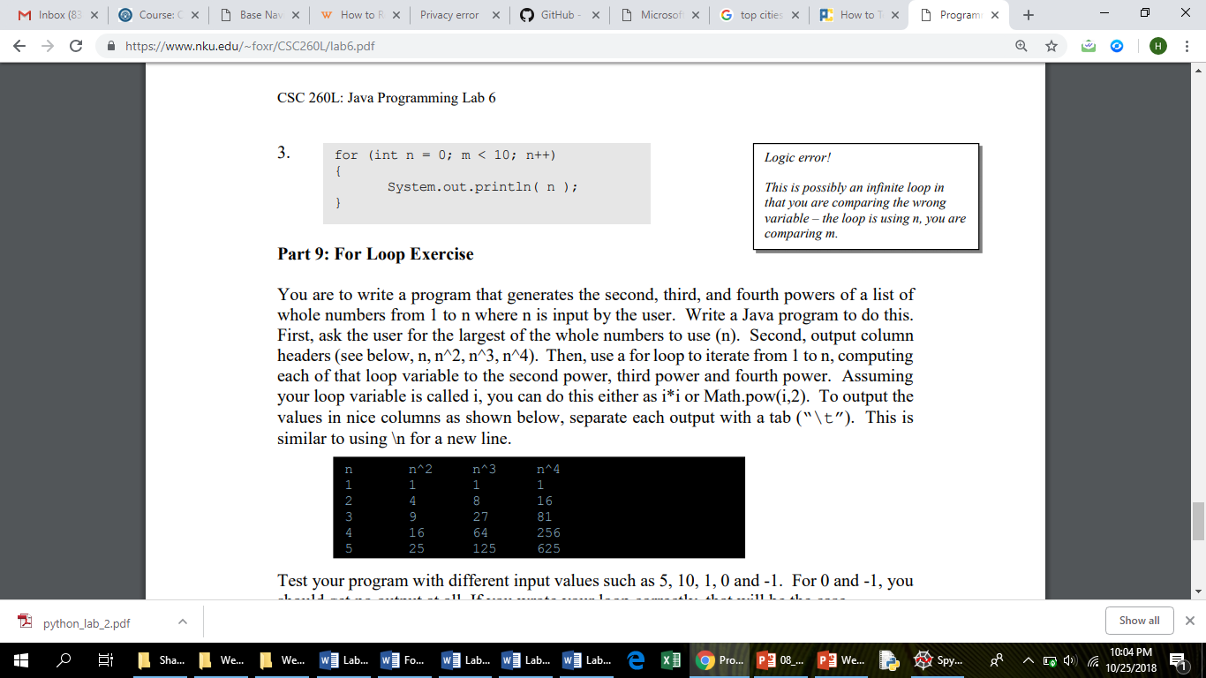

[1.5 Marks]

|  |
| --- |
| Task 7 |
| #Add your Python Script code here. [1Marks]  #Add the snap of tasks execution here. [0.5 Mark] |

**Deliverables**

Compile a single Word document by filling in the solution/answer part (as directed) along with the snapshots. Name your submission file as given below and submit this Word file on LMS before the deadline.

**Name – Registration No. – Section**

**Name: HAMID AYUB**

**Regt. No.: 12933118**

**Section: BESE_9B**

**Grade Criteria**

This lab is graded. Min marks: 0. Max marks: 10.

|  |  |  |
| --- | --- | --- |
| **Activity** | **Minimum** | **Maximum** |
| Documentation with clearly defined understanding of the lab task and approach | Fail | Pass |
| Task 1 | 0 | 1.5 |
| Task 2 | 0 | 1.0 |
| Task 3 | 0 | 2.0 |
| Task 4 | 0 | 1.0 |
| Task 5 | 0 | 2.0 |
| Task 6 | 0 | 1.0 |
| Task 7 | 0 | 1.5 |